AI LAB
CP – 1
NAME: ALI MALIK
REG NO. L1S23BSCS0014

QUESTION 1

Task 1:

fact = 1
n = int(input("Enter non negative number: "))
if n < 0:
print("Factorial is not defined for numbers less than 0")
else:
for i in range(1, n + 1):
fact = fact * i

print("Factorial of", n, "is:", fact)

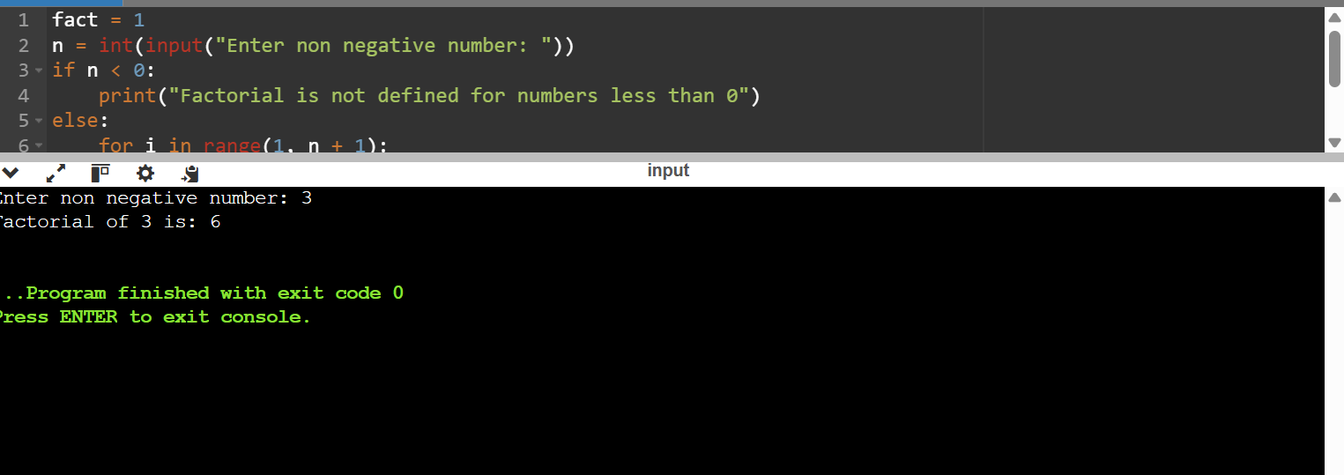

Task 2:

num = int(input("Enter a number: "))
for i in range(1, 11):
print(num, "X", i, " = ", num * i)
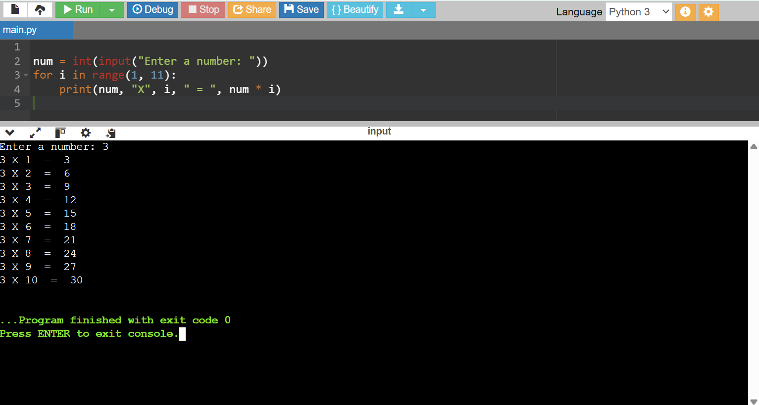

Task 3:

num1 = float(input("Enter first number: "))
num2 = float(input("Enter second number: "))

print("Select operation you wanna perform: + , - , * , /")

operator = input("Enter your choice of operation: ")

if operator == '+':
print("result is", num1 + num2)
elif operator == '-':
print("result is", num1 - num2)
elif operator == '*':
print("result is", num1 * num2)
elif operator == '/':
print("result is", num1 / num2)

else:
print("Invalid ")

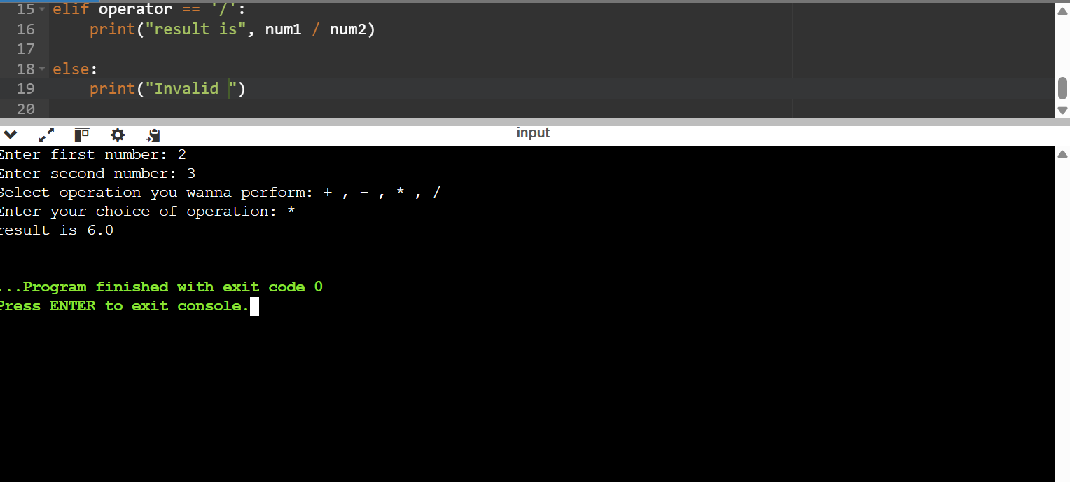

Task 4:

sentence = input("Enter a sentence: ")

words = sentence.split()

words.sort()

length = len(words)

print(" the sorted words are:")
for i in range(length):
print(words[i])
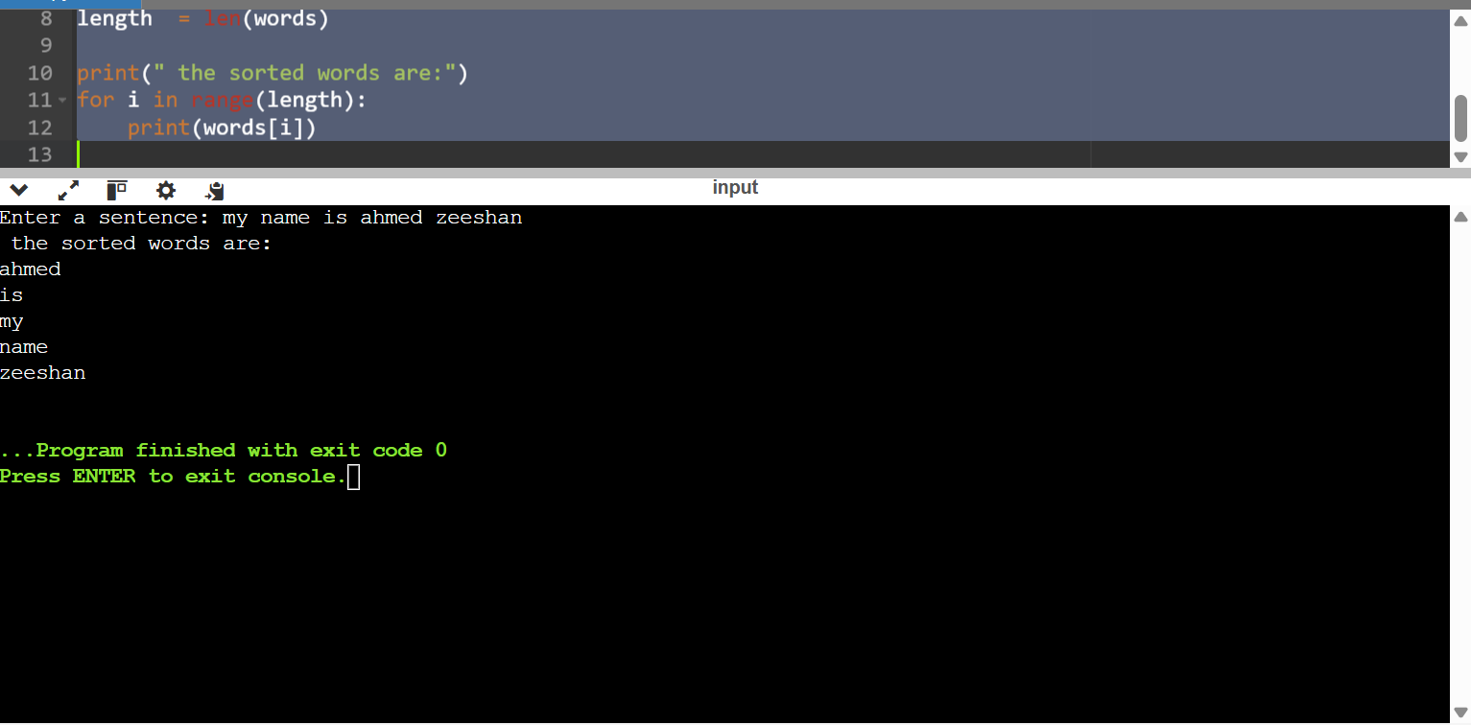

QUESTION 2

rows = int(input("Enter number of rows you want: "))

num = 1

till = rows + 1

for i in range(1, till):
for j in range(i):
print(num, end=" ")
num += 1
print("\n")

